# Installing Jaco driver in Windows 8

*The computer will restart during this process.*

1. Move your mouse to the bottom-right-corner of the screen and click "Settings".



1. Click "Change PC settings".

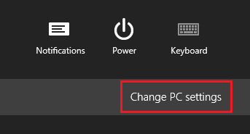

1. Click "General".
2. Scroll down and click "Restart now" under "Advanced startup".

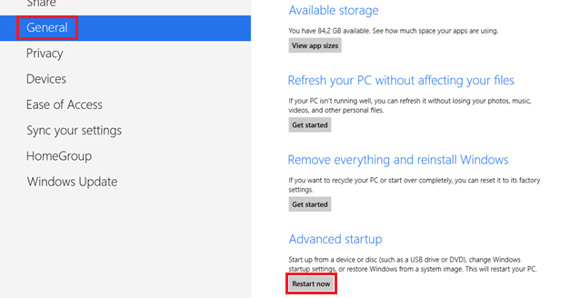

1. Click "Troubleshoot".

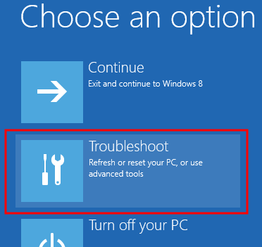

1. Click "Advanced options".

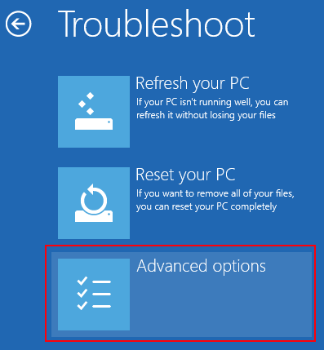

1. Click "Startup Settings".

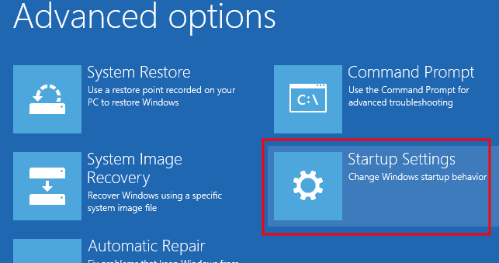

1. Click "Restart".

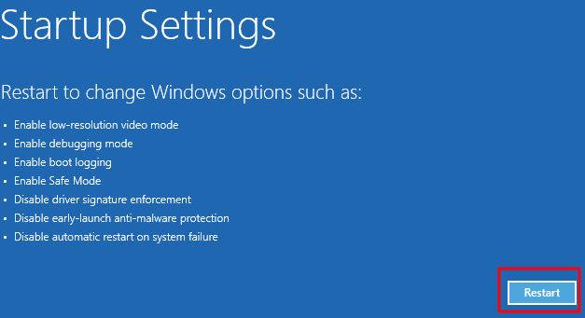

1. Press 7 for "Disable driver signature enforcement".

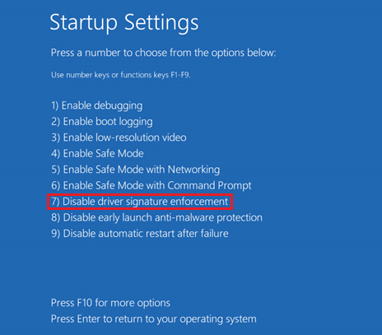

1. Install Jaco driver the same way as in Windows 7.

For easy access to the Device Manager: move your mouse to the bottom-left-corner of the screen, do a right-click and click "Device Manager".

